|  |  |
| --- | --- |
|  | |
|  | |
| [Report Title] | |
| **Module code:** | **[4 digit code]** |
| **Module name:** | **[Module name]** |
|  | |
| [Date of submission] | |
|  | |
| **Author(s):** | **[Author name]** |
| **Student ID(s):** | **[Number]** |
| **Degree:** | **[e.g. MEng Aerospace Engineering with Industry]** |
| **Tutor/Project supervisor:** | **[Name]** |
|  | |
| **CO-INVESTIGATOR: [Enter name here] [For 1st year labs only – delete this line for all other reports]** | |
| **SUPERVISOR’S COPY/EXAMINER’S COPY [For 3rd/4th year projects only - delete as appropriate] [Delete this line for all other reports]** | |

|  |
| --- |
|  |
| Summary |
| [Enter summary text here] |

Contents

1 Introduction {Paul} Real world applications , requirements 2

1.1 List of members 2

1.1 Chassis (Brad) 2

1.2 Design (Alex) 2

1.3 Powertrain (Keqi) 2

1.4 (Paul) 2

1.5 (Divine) 3

1.6 (Xiang) 0

2 The criteria derived from the specifications for the design to meet the system requirements and the rules; (Brad) 0

3 A requirement tree {Divine} 0

4 A morphological diagram or mind-map showing the range of solutions or devices considered for concepts; (Keqi) 1

5 A sketch and corresponding description of each concept presented in the first VDP meeting. The name of the "designer" should be written on the sketch together with some reference number or text to the synthesis chart 0

5.1 Chassis (Brad) 0

5.2 Design (Alex) 0

5.3 Powertrain (Keqi) 0

5.4 (Paul) 0

5.5 (Divine) 0

5.6 (Xiang) 0

6 Synthesis chart Sort of VDP2 {Do together on monday} 0

7 Materials & Pricing {Alex} 0

8 Conclusion on design After VDP2 {Xiang} does introductory paragraph 0

8.1 Chassis (Brad) 1

8.2 Design (Alex) 1

8.3 Powertrain (Keqi) 1

8.4 (Paul) 1

8.5 (Divine) 1

8.6 (Xiang) 0

# Introduction {Paul} Real world applications , requirements

The design task is to design and build a working prototype of a hovercraft following a specification, (**Link to appendix where the specification is?)** the hovercraft has set maximum dimensions and minimum weight carrying capacity so that it can be used as a model for real world situations. The design quality will be assessed through the following criteria:

1. The vehicle should be able to start/stop as required
2. The hovercraft should be able to move freely over small obstacles of height less than 5 millimetres.
3. The highest Payload Lift Capacity
4. The highest score of payload mass times distance travelled
5. The lowest overall project cost
6. The design process quality assessed by a Panel of VDPs

The hovercraft will travel in a course of dimensions 4.4mx1.2m, and travel over obstacles of a height under 5mm, there is an area with no obstacles where the hovercraft can turn. More points are scored for the amount of laps made and the load carried. 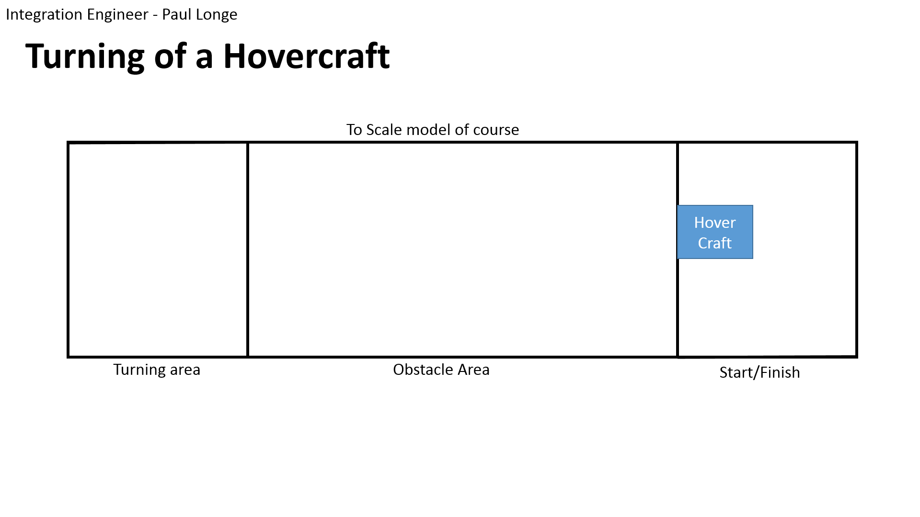

The hovercraft flies on a cushion of air, generated by a lift fan that moves the air at a low speed but high pressure. Because the hovercraft moves on this cushion of air, it experiences very little friction, and is capable as a multi-terrain vehicle. As the friction is small, very little power is required from the thrust fan, so it is also more fuel-efficient then a boat. This makes them extremely suitable for rescue missions, as an amphibious vehicle the hovercraft can operate on: mud flats, sand banks, frozen seas, around shores, and many other places that a boat or car are not able to reach. The hovercraft needs to be able to carry a load which can be people, or medicinal equipment in a rescue situation. This is why the prototype similarly has a minimum load it must be capable of carrying.

## List of members

## Chassis (Brad)

3-4sentences  
link back to spec

Roles and responsibility

## Design (Alex)

3-4sentences  
Roles and responsibility

## Powertrain (Keqi)

3-4sentences Roles and responsibility

## Paul Longe – Integration Engineer

As the Integration Engineer, I am responsible for ensuring that each member of team works together to form a cohesive solution to the problem. I have also taken the additional role of designing the mechanical components of control of the hovercraft; my main goal is to ensure that the hovercraft is capable of performing a 180° turn within the 1x1.2m area.

## (Divine)

3-4sentences Roles and responsibility

## (Xiang)

3-4sentences Roles and responsibility

# The criteria derived from the specifications for the design to meet the system requirements and the rules; {Brad}

# A requirement tree {Divine}

|  |  |  |
| --- | --- | --- |
| Wish: | Requirement: | Specification: |
|  |  |  |
|  |  |  |

# A morphological diagram or mind-map showing the range of solutions or devices considered for concepts; {Keqi}

**Blaaaaaa**

**aaaaaaaaah;**

.

# A sketch and corresponding description of each concept presented in the first VDP meeting. The name of the "designer" should be written on the sketch together with some reference number or text to the synthesis chart

## Chassis (Brad)

## Design (Alex)

## Powertrain (Keqi)

## Integration Engineer – Turning - Paul Longe

One concept was to use bow thrusters to control the craft, the basic idea is to have some of the air from the lift fan redirected through the sides of the craft so as to cause a change in direction through the principle of conservation of momentum. The lift fan needs to be powerful enough to still lift the craft while air is redirected. But a benefit of this idea is that the thrust fan can be turned off whilst the turns are made which will save on power, and reduce the effects caused by moment of inertia which allows the craft to have a smaller radius of turn.

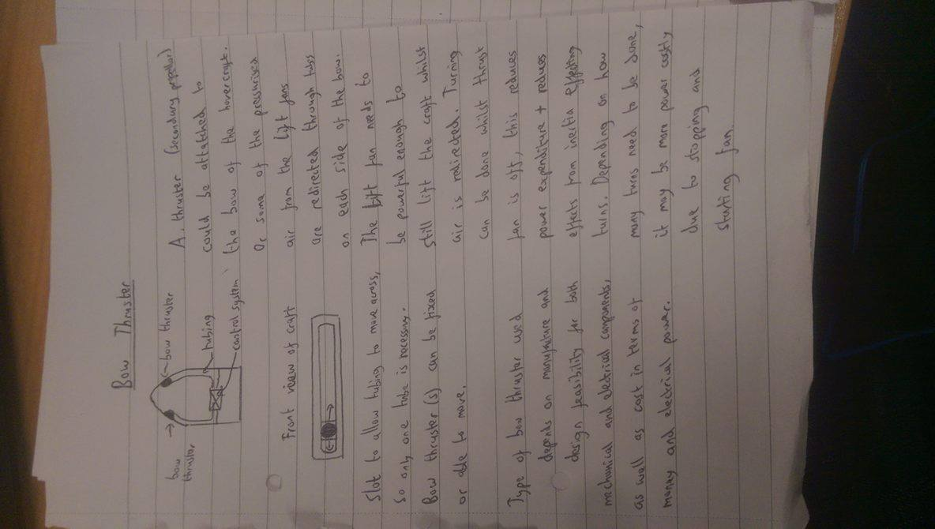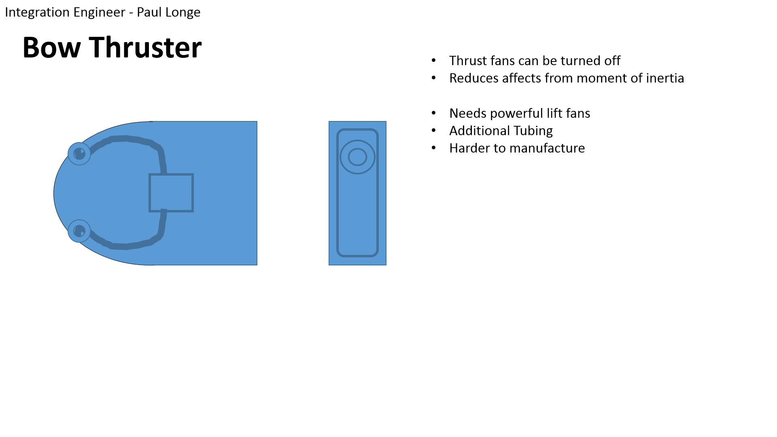

Another concept was to use rudders to redirect airflow from the thrust fan to control its direction. This would be easier to manufacture and can be freely designed to improve the quality.

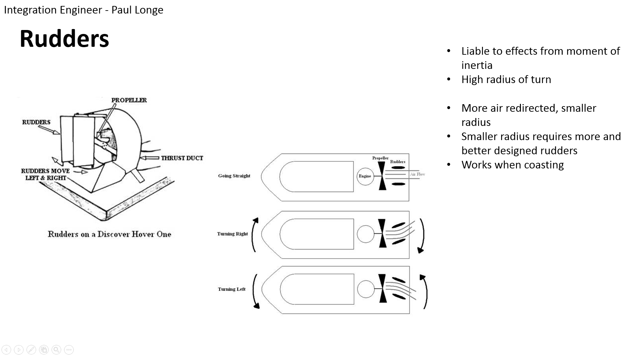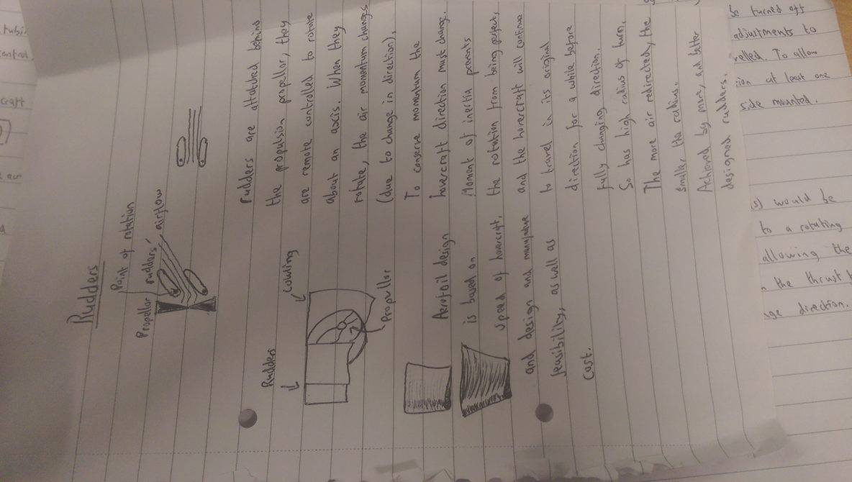

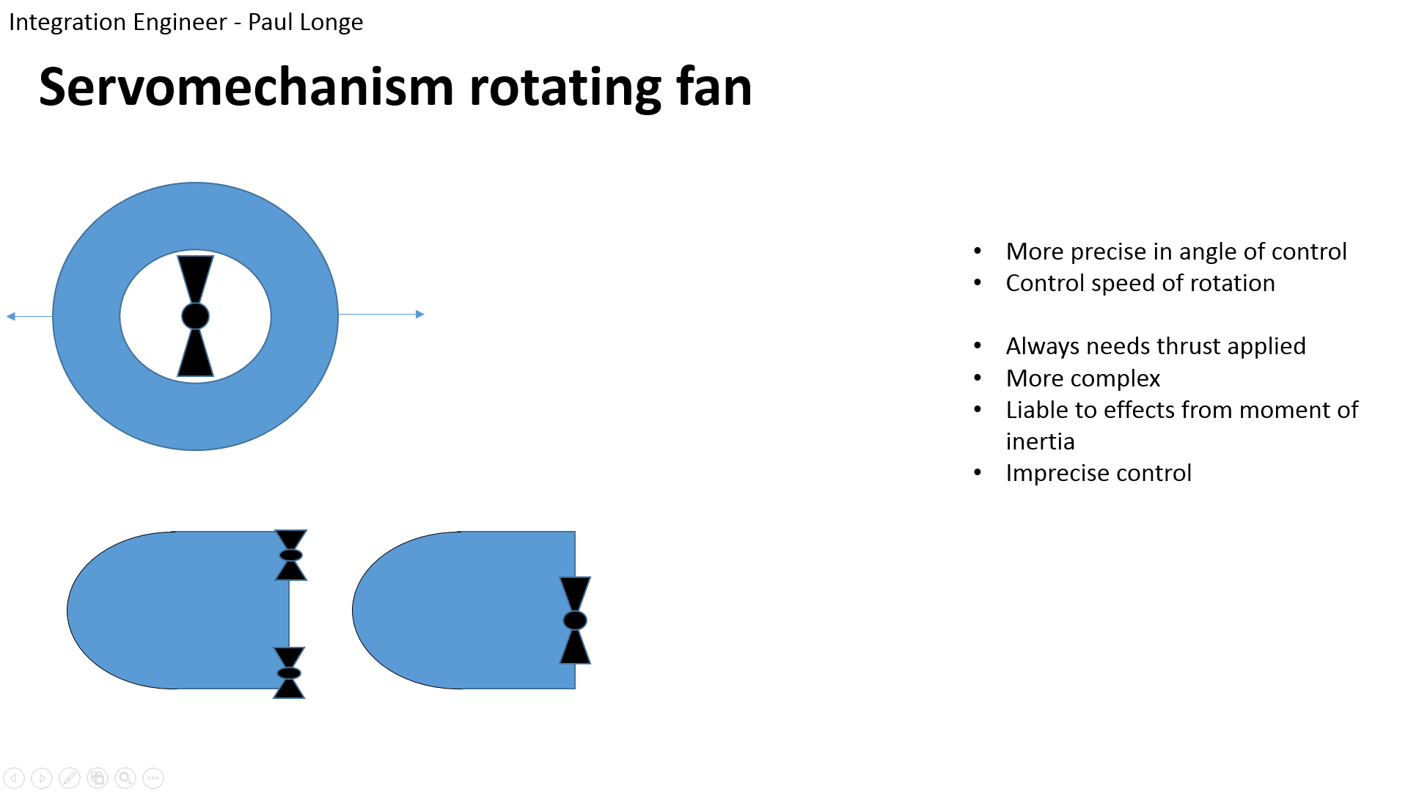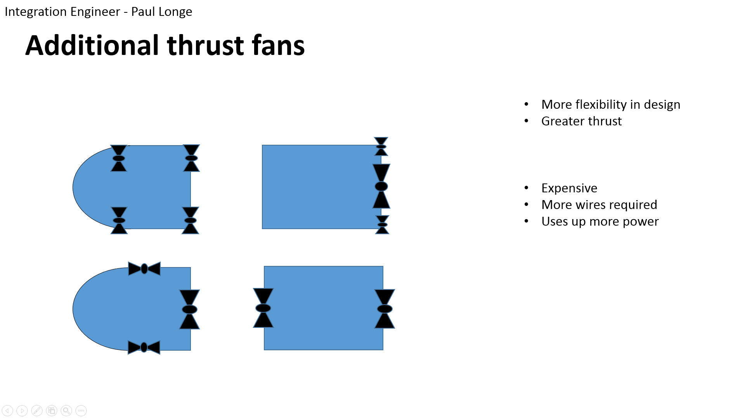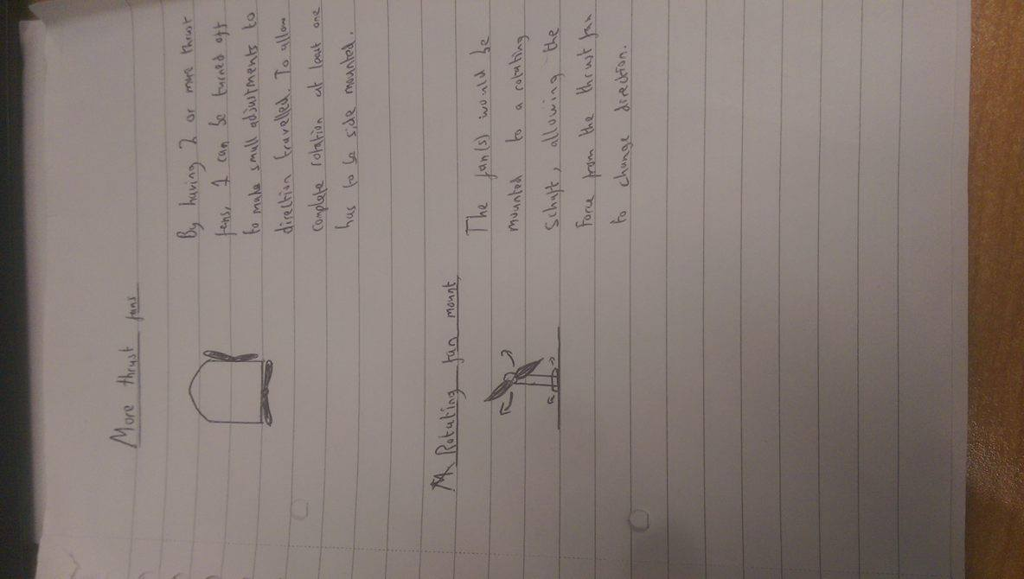

A concept was to use multiple thrust fans thrust fans which allows for several different designs as shown, but may be more expensive in terms of both cost and electrical power. The last concept was the use of a rotating fan, which is more complex to design but allows the hovercraft to stop even if the thrust fan cannot reverse direction.

## (Divine)

## (Xiang)

Calculatios (VDP2 stuff)

# Synthesis chart Sort of VDP2 {Do together on monday}

* **Completed synthesis chart ( or charts if a second iteration is attempted) showing:**
  + **The specifications considered;**
  + **The weightings for each criterion;**
  + **The marks for each design concept and the totals**

**Completed as a group**

**Bring every solid works design + sketches**

# Materials & Pricing {Alex}

Material Descision

# Conclusion on design After VDP2 {Xiang} does introductory paragraph

* **Concluding section stating the outcome of the selection process and giving outline details of the final design with the division of task to sub-groups.**

Picture of final design and more words

## Chassis (Brad)

## Design (Alex)

## Powertrain (Keqi)

## Integration engineer – Turning – Paul Longe

Following VDP2 a final design was chosen. It was decided after reviewing the design specification that rudders were the best option as they are easy and cheap to manufacture, require little electrical power to control, and as the fans have a reverse setting the hovercraft is still able to stop as required. The final concept design has dimensions as shown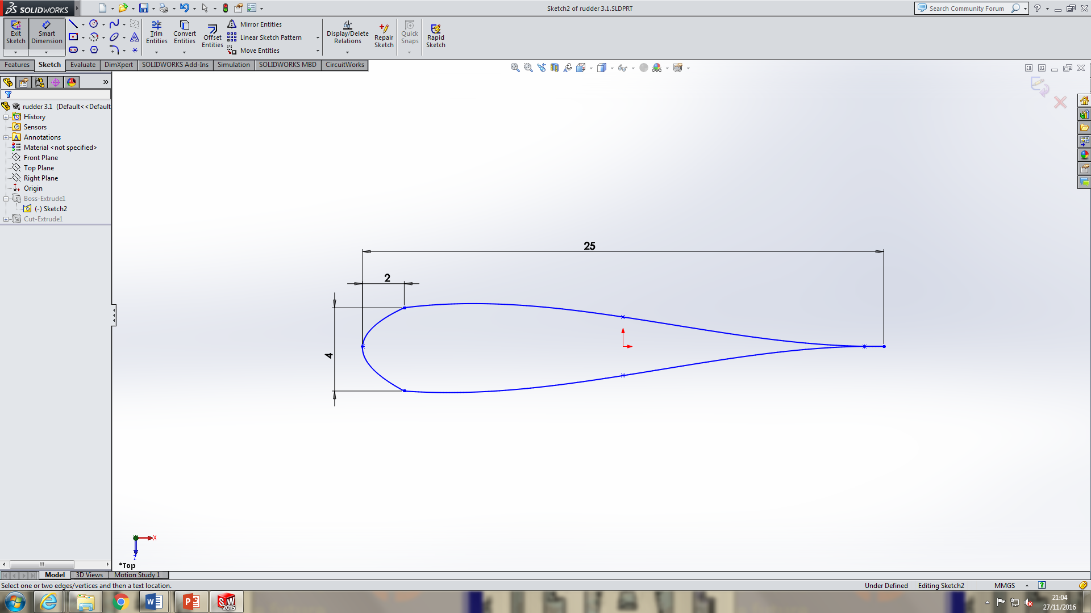, in a symmetrical aerofoil shape to redirect the most airflow possible. The rudders has a thickness of 100mm so it covers the whole of the fan area and more airflow can be redirected, the rudder is secured by a pin so it can attach to the cowling and the pin is located in the thickest part where it can bear the most load. Two rudders are to be used because the more rudders there are the greater amount of airflow can be redirected, and by only having two rudders, a large amount of air can be redirected.

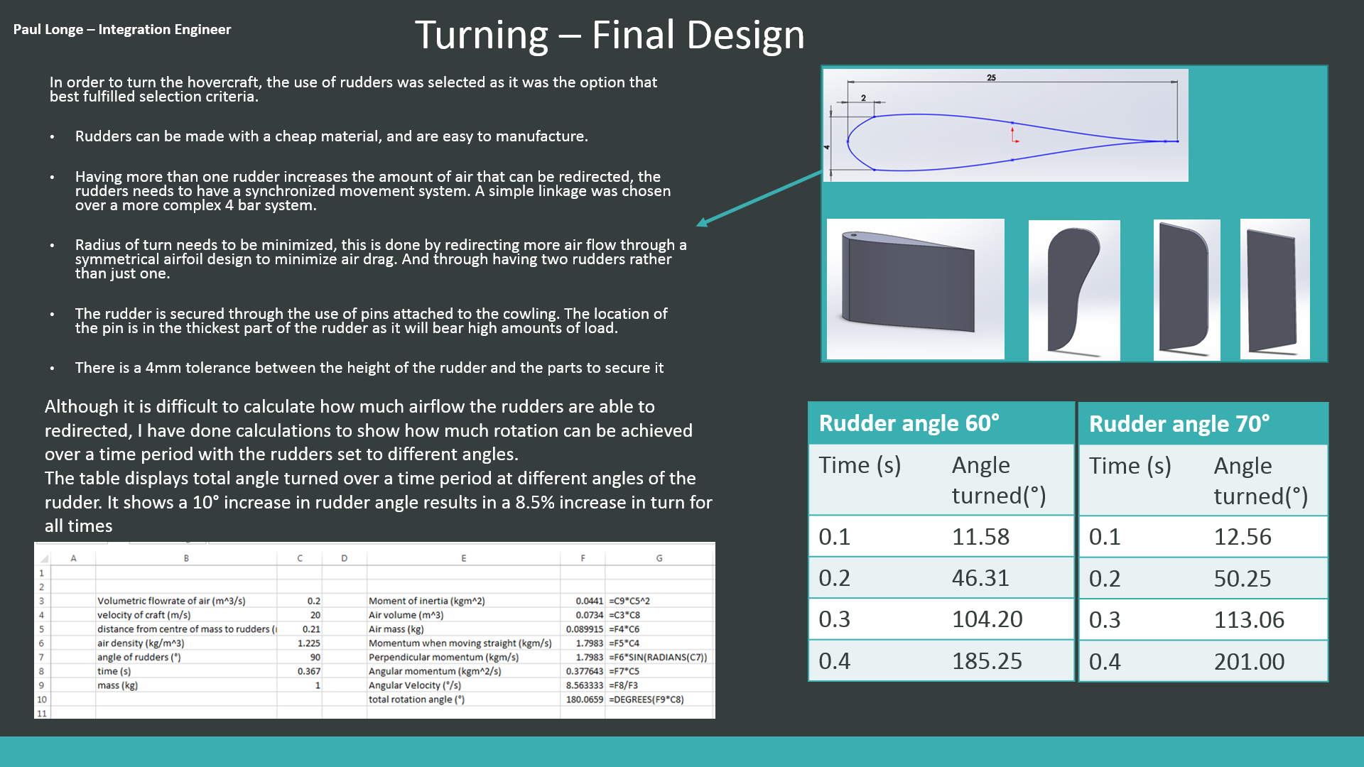

## (Divine)

## (Xiang)